Check-out integration Requirements
Besides the technical integration requirements, there are specific additional Riverty requirements related to the web store and the Riverty checkout experience that we kindly request you to implement accordingly. Please find the detailed list below:
Presentation Riverty T&Cs and Privacy Policy
The Riverty T&Cs and Privacy Policy should ideally be displayed when selecting Riverty as a payment method, but at the latest when completing the order.
If the customer first must actively select Riverty on your payment method page, no checkbox is necessary to agree to the T&Cs for the payment method.
- This display and disclaimer should be used if you do not use Profile Tracking:
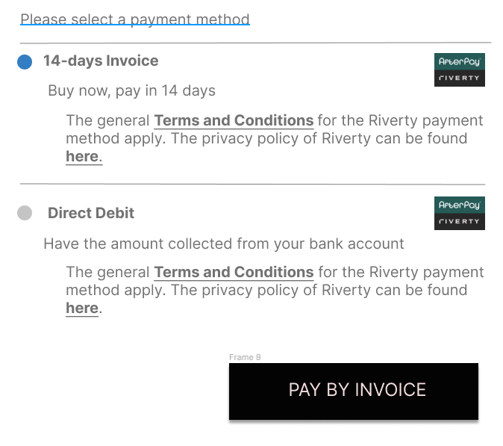

- This display and disclaimer must be used if you agreed to use Profile Tracking:
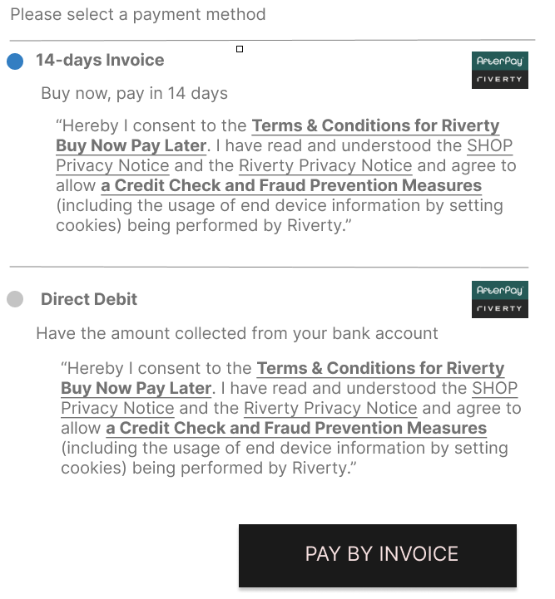

Please note that for Profile Tracking you must include a link to the Shop Privacy Notice.
English:
“Hereby I consent to the Terms & Conditions for Riverty Buy Now Pay Later. I have read and understood the SHOP Privacy Notice and the Riverty Privacy Notice and agree to allow a Credit Check and Fraud Prevention Measures (including the usage of end device information by setting cookies) being performed by Riverty.”

German:
„Ich stimme den Bedingungen für den Riverty Rechnungskauf zu. Ich habe die SHOP-Datenschutzhinweise sowie die Riverty-Datenschutzhinweise zur Kenntnis genommen und bin damit einverstanden, dass eine Bonitätsprüfung sowie Maßnahmen zur Betrugsprävention (u.a. durch Nutzung von Endgeräteinformationen durch das Setzen von Cookies) durch Riverty durchgeführt werden.“
Text and formatting unfortunately need to follow this formatting:
Credit Check and Fraud Prevention Measures must be displayed in bold and underlined.
Riverty Terms & Conditions and Privacy Policy
Privacy Policy:
https://documents.riverty.com/privacy_statement/checkout/de_de

Terms & Conditions for payment method invoice:
https://documents.riverty.com/terms_conditions/payment_methods/invoice/de_de/default

Terms & Conditions for payment method direct debit:
https://documents.riverty.com/terms_conditions/payment_methods/direct_debit/de_de/default

Terms & Conditions for payment method instalments:
The terms and conditions for instalment are a bit special as they vary depending on the instalment’s conditions.
If you integrate via a plugin, you do not need to do anything other than adding the given MerchantID with the plugin.
If you integrate directly via APIs, you will receive the tailored information from the Available Payment Method API call. For more information, please see Riverty payment method – Instalments

Specific links to our other payment methods and what text to display can be found here:
https://developer.afterpay.io/documentation/compliance-requirements-*new/

Applicable law - Client shop Terms & Conditions and Privacy Policy
There is also something to consider for your own T&Cs and data privacy policy. If you operate a store outside of Germany or Austria, e.g., with a company address in Hong Kong or Switzerland, you may have to adapt the paragraph regarding the choice of law. If you do not mention the applicable law or place of jurisdiction in your terms and conditions, you do not have to do anything. In this case, the applicable law of the country in which the buyer resides automatically applies. However, if you set out applicable law, arbitration clause, jury trial or similar in your T&C, then German or Austrian law must apply for customers residing in Germany or Austria. This requirement is necessary, otherwise Riverty cannot purchase your receivables.
If you have any further questions about this, please feel free to contact your Riverty Integration Manager.

Riverty Logo
Please use this link to implement the logo:
https://cdn.riverty.design/logo/riverty-checkout-logo.svg

Riverty logo as a payment method in your Webshop

The Riverty logo should be embedded on the home page of your web store along with other payment options. Most often, the payment methods offered in the store are mentioned in the footer of the home page.
Example 1:

Riverty Logo in your shopping cart
If you already display the logos of the various payment methods in your shopping cart, the Riverty logo must also be integrated here.

Example 2:
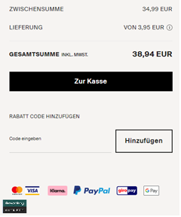

Riverty logo in Checkout
The Riverty logo must be displayed in the checkout when selecting the payment method.
Example 3:

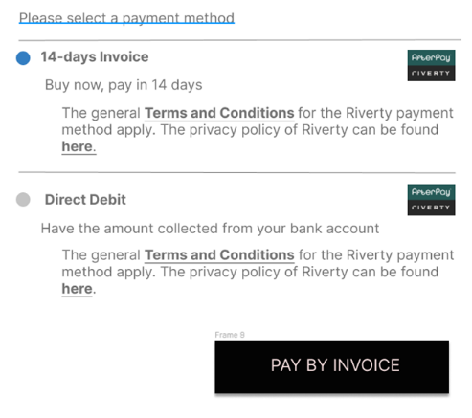

Riverty payment method - Invoice
We recommend using only the Riverty logo and the term " 14-days invoice" when purchasing on account. The payment method can also be extended with an explanation matching your product portfolio:
Example 4:
- INVOICE, try it on first, pay later.
- INVOICE, receive first, pay later.
- INVOICE, experience first, pay 14 days later.

Riverty payment method – Instalments
To ensure transparency and compliance with regulations, it is necessary to display comprehensive information regarding instalment payment options in your store, including interest rates, fees, and the total amount to be paid.
You can retrieve the necessary data from the Available Payment Method call.
In addition, it is essential to include a disclaimer that provides appropriate information.
Here you can find the Pflichtangaben nach § 507 BGB, the Standardinformationen für Verbraucherkredite and the Datenschutzerklärung von Riverty. The Allgemeinen Geschäftsbedingungen für Riverty Fix apply.

Links (Instalments):
- Pflichtangaben nach § 507 BGB:
https://documents.riverty.com/terms_conditions/payment_methods/fix_instalments/de_de/bgb507
- Datenschutzerklärung von Riverty:
https://documents.riverty.com/privacy_statement/checkout/de_de
- Standardinformationen für Verbraucherkredite:
The link will be provided to you via the Available Payment API call
- Allgemeinen Geschäftsbedingungen für Riverty Fix :
the link will be provided to you via the Available Payment API call

Example of an Instalment checkout design:
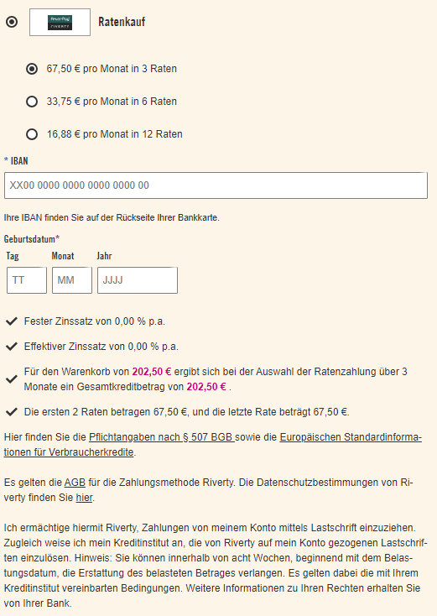
Data transmission
Here is a list of minimum information you contractually agreed on to transmit:
Capture / Refund / Void:
- order number
- invoice number (if available, otherwise created by Riverty)
- credit note number (if available, otherwise created by Riverty)
- total amount (gross / net)
- tracking number (if available)
At item level:
- unique identifier of the item (product group, product ID)
- Item description with brand name and product name e.g., Hugo Boss – T-Shirt
- quantity
- unit price (gross / net)
- VAT rate
- VAT amount
The following API services must be used:
CAPTURE:
Riverty must be informed about the dispatched items (partial or full dispatch). Capture must occur immediately after the handing over of goods to the logistics service provider, but at the latest within the period
REFUND:
In the event the Customer returns the goods, Riverty must be informed about the returned items (partial or full return).
VOID:
If an order is not shipped completely (e.g., due to certain items being out of stock) or if the order or parts thereof have been cancelled before shipment, this must be communicated to Riverty, so that the reserved amount can be released from the Customer’s total available amount.

